LAB 5 FIRST Q

#include <stdio.h>

#include <stdlib.h>

struct Node {

int data;

struct Node\* next;

};

struct Node\* createNode(int value) {

struct Node\* newNode = (struct Node\*)malloc(sizeof(struct Node));

newNode->data = value;

newNode->next = NULL;

return newNode;

}

void insertEnd(struct Node\*\* head, int value) {

struct Node\* newNode = createNode(value);

if (\*head == NULL) {

\*head = newNode;

} else {

struct Node\* temp = \*head;

while (temp->next != NULL) {

temp = temp->next;

}

temp->next = newNode;

}

}

void display(struct Node\* head) {

struct Node\* temp = head;

while (temp != NULL) {

printf("%d -> ", temp->data);

temp = temp->next;

}

printf("NULL\n");

}

void sortLinkedList(struct Node\* head) {

int swapped, i;

struct Node\* ptr;

struct Node\* lptr = NULL;

if (head == NULL)

return;

do {

swapped = 0;

ptr = head;

while (ptr->next != lptr) {

if (ptr->data > ptr->next->data) {

int temp = ptr->data;

ptr->data = ptr->next->data;

ptr->next->data = temp;

swapped = 1;

}

ptr = ptr->next;

}

lptr = ptr;

} while (swapped);

}

struct Node\* reverseLinkedList(struct Node\* head) {

struct Node \*prev = NULL, \*current = head, \*next = NULL;

while (current != NULL) {

next = current->next;

current->next = prev;

prev = current;

current = next;

}

return prev;

}

void concatenateLinkedLists(struct Node\*\* list1, struct Node\* list2) {

if (\*list1 == NULL) {

\*list1 = list2;

} else {

struct Node\* temp = \*list1;

while (temp->next != NULL) {

temp = temp->next;

}

temp->next = list2;

}

}

int main() {

struct Node\* list1 = NULL;

struct Node\* list2 = NULL;

int n, value;

printf("Enter the number of elements for list 1: ");

scanf("%d", &n);

printf("Enter the elements for list 1:\n");

for (int i = 0; i < n; i++) {

scanf("%d", &value);

insertEnd(&list1, value);

}

printf("Enter the number of elements for list 2: ");

scanf("%d", &n);

printf("Enter the elements for list 2:\n");

for (int i = 0; i < n; i++) {

scanf("%d", &value);

insertEnd(&list2, value);

}

sortLinkedList(list1);

printf("Sorted List 1: ");

display(list1);

list2 = reverseLinkedList(list2);

printf("Reversed List 2: ");

display(list2);

concatenateLinkedLists(&list1, list2);

printf("Concatenated List: ");

display(list1);

struct Node\* temp;

while (list1 != NULL) {

temp = list1;

list1 = list1->next;

free(temp);

}

return 0;

}

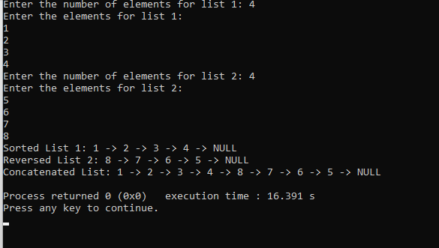

STACK IMPLEMENTATION:

#include <stdio.h>

#include <stdlib.h>

struct Node {

int data;

struct Node\* next;

};

struct Node\* createNode(int value) {

struct Node\* newNode = (struct Node\*)malloc(sizeof(struct Node));

newNode->data = value;

newNode->next = NULL;

return newNode;

}

void push(struct Node\*\* top, int value) {

struct Node\* newNode = createNode(value);

newNode->next = \*top;

\*top = newNode;

}

int pop(struct Node\*\* top) {

if (\*top == NULL) {

printf("Stack underflow!\n");

return -1;

}

struct Node\* temp = \*top;

int poppedValue = temp->data;

\*top = temp->next;

free(temp);

return poppedValue;

}

void displayStack(struct Node\* top) {

printf("Stack: ");

while (top != NULL) {

printf("%d ", top->data);

top = top->next;

}

printf("\n");

}

int main() {

struct Node\* top = NULL;

int choice, value;

do {

printf("\nStack Operations:\n");

printf("1. Push\n");

printf("2. Pop\n");

printf("3. Display\n");

printf("4. Exit\n");

printf("Enter your choice: ");

scanf("%d", &choice);

switch (choice) {

case 1:

printf("Enter the value to push: ");

scanf("%d", &value);

push(&top, value);

break;

case 2:

value = pop(&top);

if (value != -1) {

printf("Popped value: %d\n", value);

}

break;

case 3:

displayStack(top);

break;

case 4:

printf("Exiting the program.\n");

break;

default:

printf("Invalid choice! Please enter a valid option.\n");

}

} while (choice != 4);

struct Node\* temp;

while (top != NULL) {

temp = top;

top = top->next;

free(temp);

}

return 0;

}

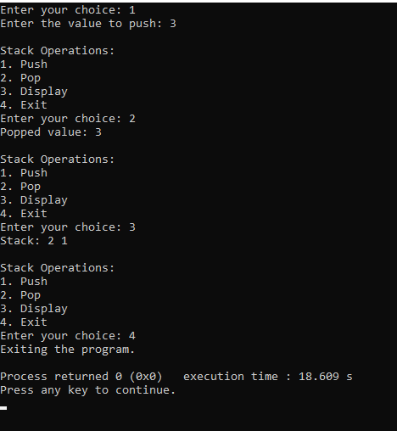

QUEUE IMPLEMENTATION:

#include <stdio.h>  
#include <stdlib.h>  
struct Node {  
    int data;  
    struct Node\* next;  
};  
struct Queue {  
    struct Node\* front;  
    struct Node\* rear;  
};  
struct Node\* createNode(int value) {  
    struct Node\* newNode = (struct Node\*)malloc(sizeof(struct Node));  
    newNode->data = value;  
    newNode->next = NULL;  
    return newNode;  
}  
struct Queue\* createQueue() {  
    struct Queue\* queue = (struct Queue\*)malloc(sizeof(struct Queue));  
    queue->front = queue->rear = NULL;  
    return queue;  
}  
void enqueue(struct Queue\* queue, int value) {  
    struct Node\* newNode = createNode(value);  
    if (queue->rear == NULL) {  
        queue->front = queue->rear = newNode;  
        return;  
    }  
    queue->rear->next = newNode;  
    queue->rear = newNode;  
}  
int dequeue(struct Queue\* queue) {  
    if (queue->front == NULL) {  
        printf("Queue underflow!\n");  
        return -1;  
    }  
    struct Node\* temp = queue->front;  
    int dequeuedValue = temp->data;  
    queue->front = temp->next;  
    if (queue->front == NULL) {  
        queue->rear = NULL;  
    }  
    free(temp);  
    return dequeuedValue;  
}  
void displayQueue(struct Queue\* queue) {  
    struct Node\* temp = queue->front;  
    printf("Queue: ");  
    while (temp != NULL) {  
        printf("%d ", temp->data);  
        temp = temp->next;  
    }  
    printf("\n");  
}  
int main() {  
    struct Queue\* queue = createQueue();  
    int choice, value;  
    do {  
        printf("\nQueue Operations:\n");  
        printf("1. Enqueue\n");  
        printf("2. Dequeue\n");  
        printf("3. Display\n");  
        printf("4. Exit\n");  
        printf("Enter your choice: ");  
        scanf("%d", &choice);  
        switch (choice) {  
            case 1:  
                printf("Enter the value to enqueue: ");  
                scanf("%d", &value);  
                enqueue(queue, value);  
                break;  
            case 2:  
                value = dequeue(queue);  
                if (value != -1) {  
                    printf("Dequeued value: %d\n", value);  
                }  
                break;  
            case 3:  
                displayQueue(queue);  
                break;  
            case 4:  
                printf("Exiting the program.\n");  
                break;  
            default:  
                printf("Invalid choice! Please enter a valid option.\n");  
        }  
    } while (choice != 4);  
    struct Node\* temp;  
    while (queue->front != NULL) {  
        temp = queue->front;  
        queue->front = queue->front->next;  
        free(temp);  
    }  
    free(queue);  
    return 0;  
}

OUTPUT:

